License Validity of CHA

Check on the validity of CHA license and an option to update the renewed license and manage profile has been implemented in CHA’s Profile Page. Below mentioned are the Scenarios and series of Steps:

CASE 1: License is about to expire in less than or equal to 30 days.
A Message is displayed on the Home page of CHA indicating the number of days left for License Validity as below:
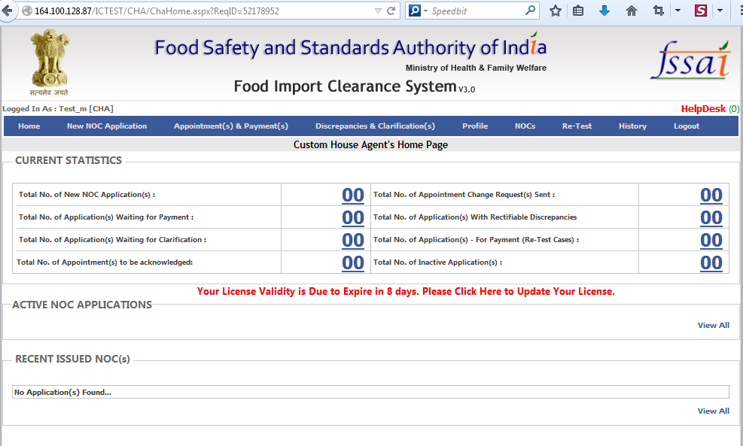

Clicking on the Message CHA is redirected to Update Profile Page as below:
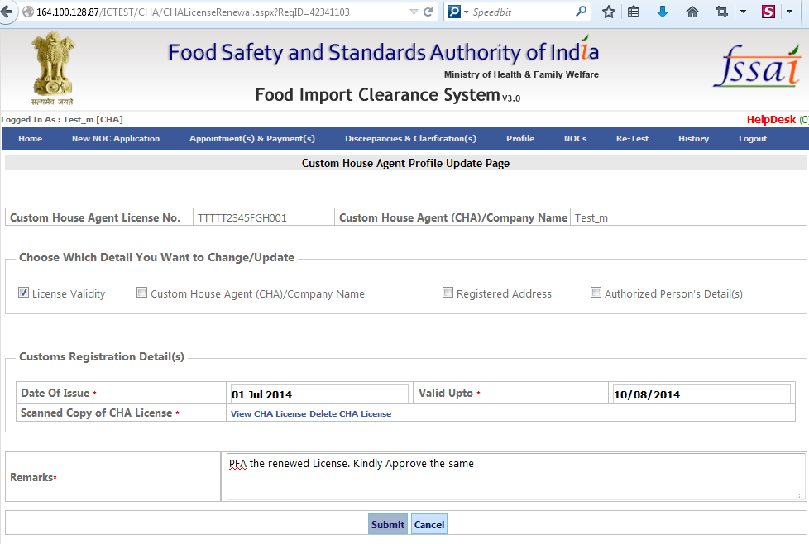
On this Page after attaching the Renewed License and entering the Mandatory fields CHA can submit the request to update the renewed License and the below message would appear:
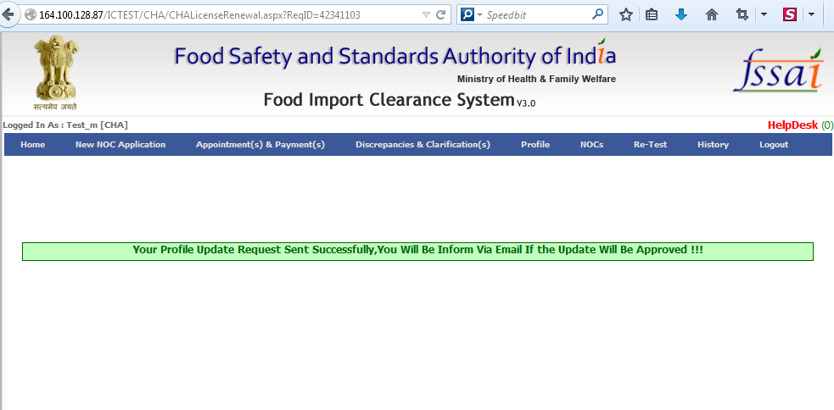
Similarly CHA can request for updating other Details like CHA Company Name, Registered Address and Authorized Person details by checking on the corresponding Check boxes in update Profile Page and providing with the updated details along with the Supporting Documents for the same if any.
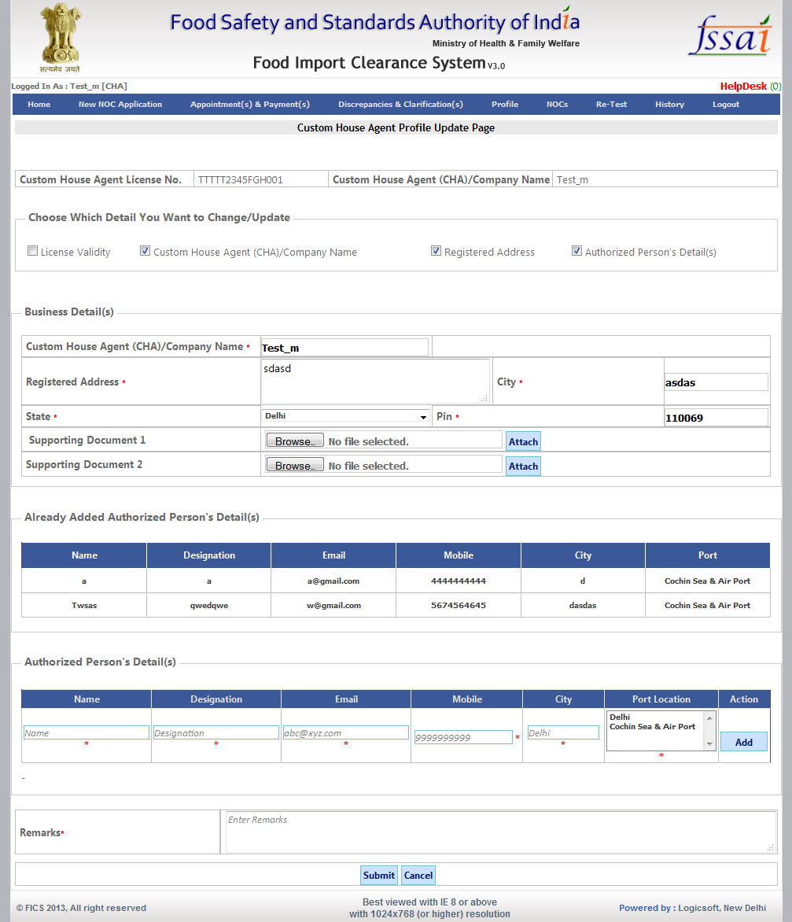
CHA can also access the Update Profile Page by clicking on the Update Profile link provided on CHA’s Profile Page as below:
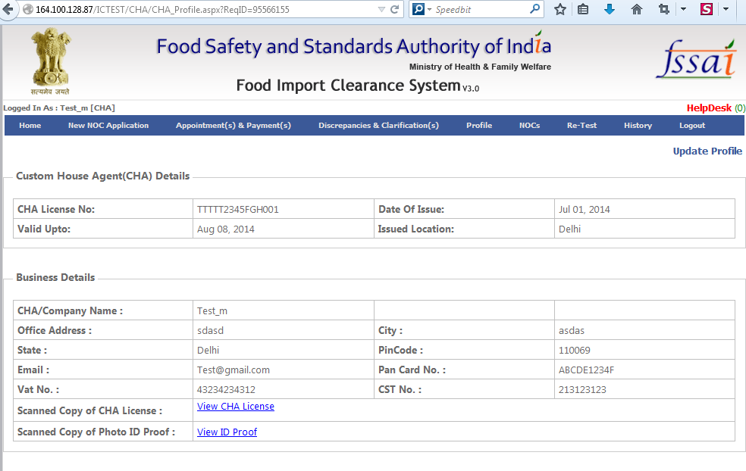
Now AO has to approve the CHA Profile update request in order for the same to be reflected in CHA’s Account. AO can access the requests for Approval by Clicking on CHA Profile Change for Approval bin as below:
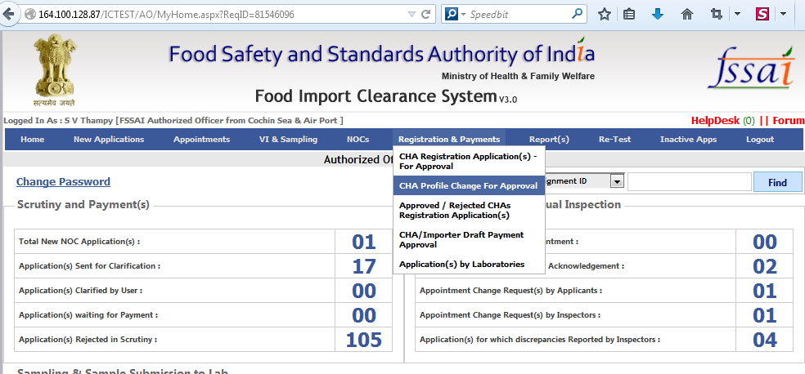

Clicking on the CHA Profile Change for Approval bin below page will appear:
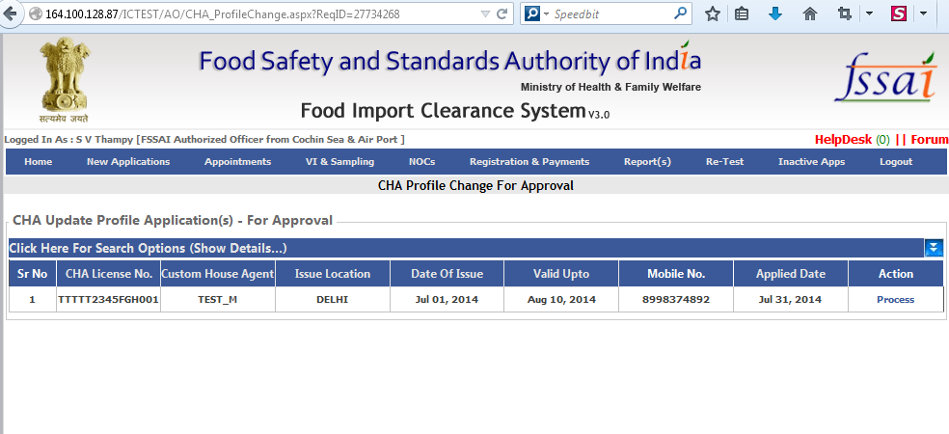

Clicking on Process below page will appear:
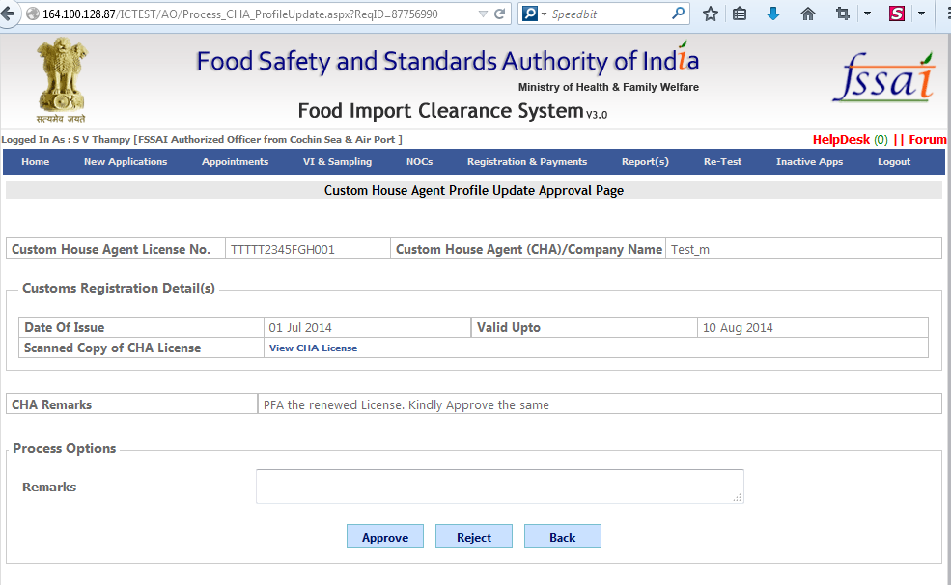

AO can Approve or Reject the request based on his discretion. Remark is Mandatory in case of Rejection.
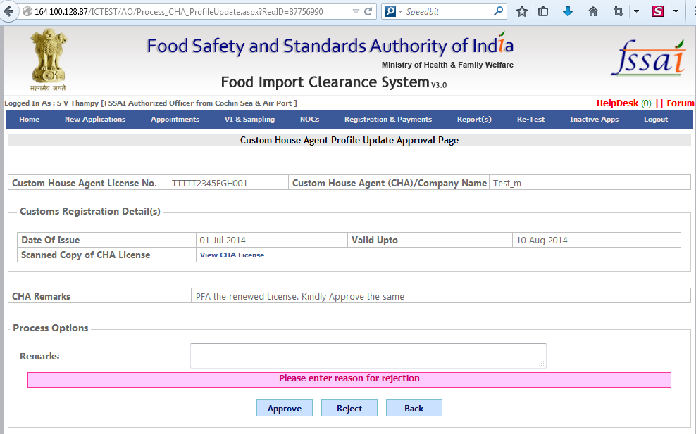

On Approving the Request Below message would appear:

Once the AO Approves/Rejects the profile update the CHA will be intimated about the same through an email as below:

CASE 2: CHA License validity has been expired
The Message displayed on Home Page indicated that the License has already expired:
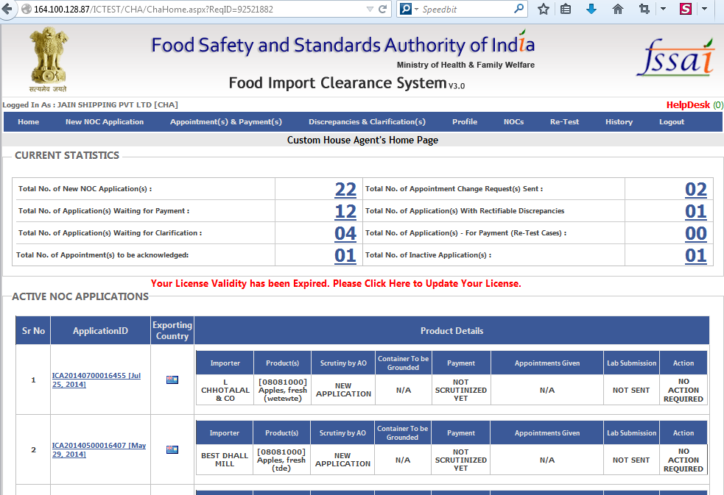

In Case the CHA ignores/ overlooks the message and continue to file a New application By Clicking on New NOC Application he/she would be automatically redirected to Update Profile Page Showing the message that he/she is unable to file the application since the License validity has been expired and needs to be updated.
